LimeDot Web Shop
www.limedot.com
1-800-294-8449

Setting up Outlook for E-mail
(Note that graphics in this tutorial may appear slightly different in your Outlook, depending on the version you are using. However, the same information should be present.)

- Open Outlook. (If this is the first time you’ve ever opened Outlook, the program may present a wizard or helper attempting to assist you in setup. Deny these offers, and move forward until you are out of the wizard. You’ll end up with the Outlook program simply open, where you’ll manually set up your e-mail.)

- At the top, click on Tools, then E-Mail Accounts. A dialog box will appear. Choose the option to “Add a new e-mail account”. Click the option for “POP3” then click “Next”.

- Fill out the information like below. Of note, “Your Name” should be the name you want people to see when receiving e-mail from you. The incoming and outgoing mail servers should be the same (mail.yourdomain.com). If you e-mail address is bob@somecompany.org, your mail server should be mail.somecompany.org. For the “User Name” enter your FULL e-mail address, even if the program populates that field with only the first part of your e-mail address. Check only the “Remember password” box.

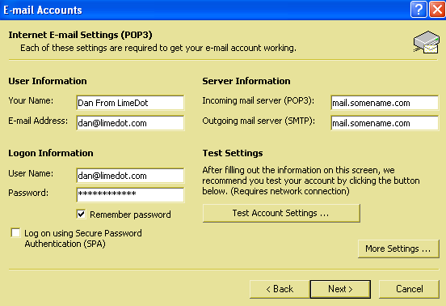

- From the dialog box above, click “More Settings”. Under the general tab (see below), name your mail account. No one will see this but you – it’s helpful for future organization if you ever add other e-mail accounts.
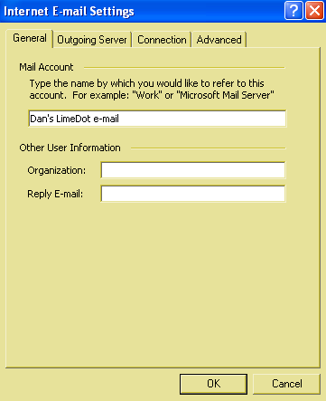
Then choose the “Outgoing Server” tab (see below) and mark the boxes as noted below.
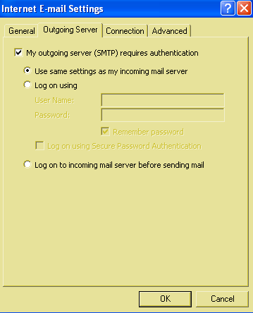
Next choose the “Advanced” tab (no image provided here). Depending on personal preference, you may choose to “leave a copy of message on the server”, or “remove from server when deleted from deleted items”. This is often handy if you frequently check this e-mail account using some webmail program. Otherwise, there is no action required by you on this tab.
Of note, e-mails always “live” on the server until you “grab” them from the server by receiving them in Outlook. Once Outlook has them, they only “live” in Outlook and are no longer on the server. Thus, if you go back to webmail, you’ll see no messages. That is, unless you have the “leave a copy of messages on the server” checked.
5. Click “OK” to close this dialog box, then “next” from the still-open previous dialog box. This will complete the set-up process.
You’re done. Use the standard, user-friendly options of Outlook to create new mail, and send/receive.
Notes: When Outlook is open, you can set it to automatically send and receive mail at set times. We recommend setting this to every few minutes. Go to Tools then Options, then the Mail Setup tab. Click the “Send/Receive” button. You may choose to set your options up as presented below:

